**Testing - Exam style question**

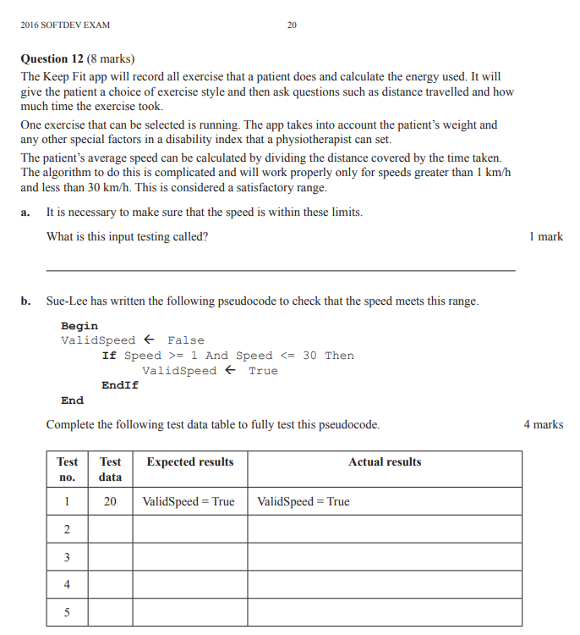

|  |  |  |  |
| --- | --- | --- | --- |
| **Test no.** | **Test Data** | **Expected result** | **Actual result** |
| **1** | 20 | ValidSpeed = True | ValidSpeed = True |
| **2** | 30 | ValidSpeed = False | ValidSpeed = True |
| **3** | 1 | ValidSpeed = False | ValidSpeed = True |
| **4** | 0 | ValidSpeed = False | ValidSpeed = False |
| **5** | 35 | ValidSpeed = False | ValidSpeed = False |

C. the condition is incorrect The equal signs associated with the greater and less sign caused the error

D.

**Begin**

ValidSpeed ← False

**If** Speed > 1 **And** Speed < 30 **Then**

ValidSpeed ← True

**EndIf**

**End**